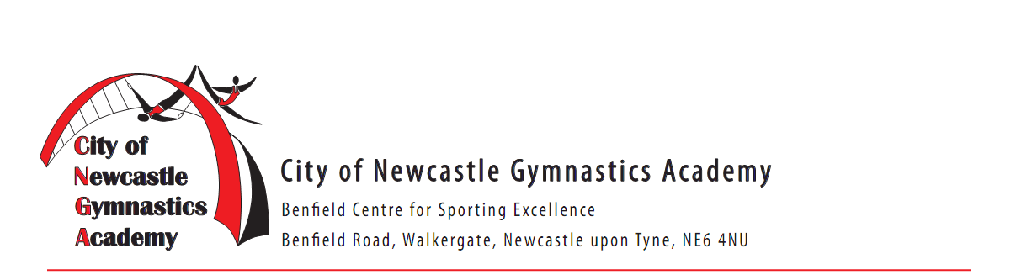
FULL NAME OF CHILD ____________________________________________ M/F ____
ADDRESS _____________________________________________________________________________
TOWN ____________________ COUNTY ______________ POSTCODE_________________________
HOME TELEPHONE__________________________ D.O.B_____________________
EMAIL ________________________________________
MEDICAL CONDITIONS
1) I confirm that I am physically fit and healthy to participate YES/NO
2) Do you have a special needs or medical condition? YES/NO
If you have answered YES to questions 2, please state medical conditions____________________________
EMERGENCY CONTACT NUMBER:
Name____________________________ Relationship to child ________________________ No: ___________

Tel: 0191 275 5113 Email: contact@newcastlegymnastics.org

CNGA Easter Camps
8th April – 18th April 2019

We Look Forward To Seeing You There!
We look forward to seeing you there!

Tel: 0191 275 5113 Email: contact@newcastlegymnastics.org

@cngagym

/CityofNewcastleGymnasticsAcademy

@Newcastlegymnastics
Booking FORM
April Easter Recreational Camps 2019
8th April – 18th April

CNGA Recreational
Easter Camps 2019

Option | Time | Price Per Day
Morning Only | 9.00am -12.00pm | £12.00
Afternoon Only | 1.00pm-4.00pm | £12.00
Morning  +Lunch Supervision | 9am-1.00pm | £15.00
All day  5+ Years Old | 9.00am-4.00pm | £24.00
Gymnasts must provide their own lunch

Childs Name: _____________________________
D.O.B:_____________________________
Contact Number: _____________________________

Week 1 | Monday 8th April | Tuesday 9th April | Wednesday 10th April | Thursday 11th April | Friday 12th April
AM
PM

Week 2 | Monday 15th April | Tuesday 16th April | Wednesday 17th April | Thursday 18th April
AM
PM

PHOTOS – we may take photos of the children in the gym and place them on our social media platforms for promotional purposes. Please tick the box if you DO NOT want us to take photos of your child.

Gymnasts must provide their own lunch

